Directions: Write the equations of the piecewise functions whose graphs are given below.

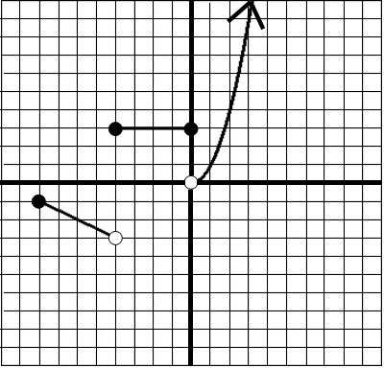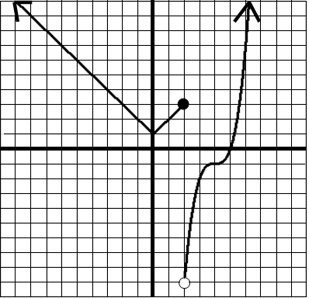

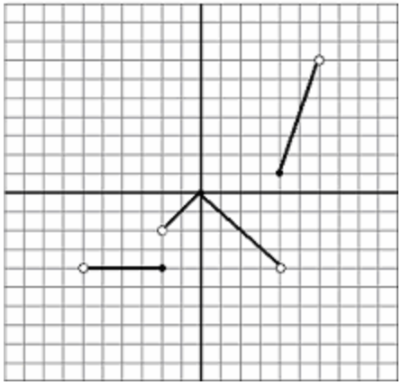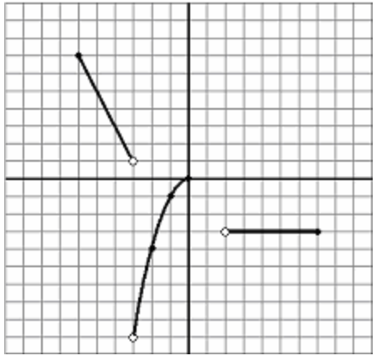

$f\left(x\right)=\begin{aligned}\left\{ | \right.\left\{ | \right.\left\{ | \right.\left\{ | \right.\end{aligned}$ $f\left(x\right)=\begin{aligned}\left\{ | \right.\left\{ | \right.\left\{ | \right.\left\{ | \right.\end{aligned}$

$f\left(x\right)=\begin{aligned}\left\{ | \right.\left\{ | \right.\left\{ | \right.\left\{ | \right.\end{aligned}$ $f\left(x\right)=\begin{aligned}\left\{ | \right.\left\{ | \right.\left\{ | \right.\left\{ | \right.\end{aligned}$

$f\left(x\right)=\begin{aligned}\left\{ | \right.\left\{ | \right.\left\{ | \right.\left\{ | \right.\end{aligned}$ $f\left(x\right)=\begin{aligned}\left\{ | \right.\left\{ | \right.\left\{ | \right.\left\{ | \right.\end{aligned}$

